Debugging the Frogger Game

# Bug 1 – All lives are lost when hit

Whether you hit any vehicle or jump into the water and die, you continue to lose lives when dead till the game is over.

## Cause of Bug

This is because the frog’s position does not reset when the game begins again, and therefore is still in contact with the object that makes it die. In turn, all lives are lost, and the game is over

## Fixing the bug

To fix the bug, I had to pass the right function as the unpause function. Originally, a new life was passed instead of rest the frog’s position.I also had to make sure that the controller caused the view to decrease the number of lives visually.

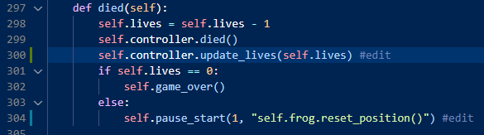

# Bug 2 – Game objects do not move when game over

When the game is over, and the game is restarted, the objects do not move anymore.

## Cause of the bug

The cause of this is the Boolean game_running being set to false when the method game_over is executed, but is not set back to True when the game is restarted, causing the objects to be static.

## Fixing the bug

When reset_level is executed, I changed the game_running Boolean to true.

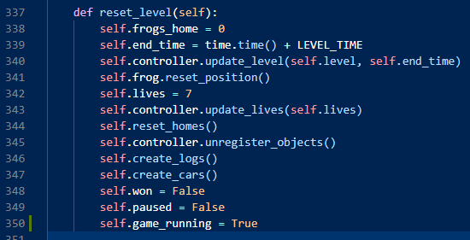

# Bug 3 – Frog dies on a turtle and log

When the frog jumps onto a turtle, it dies, and a life is lost.

## Cause of bug

The error caused was a syntax error. Instead of onlog being used, the variable onlong was created.

Fixing the bug

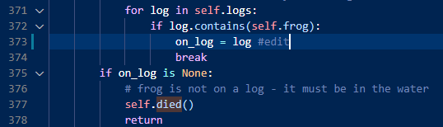

# Bug 4 – Leftmost home causes death and life is lost

When the frog jumps into the leftmost home, a life is lost, and the frog’s position is reset.

## Cause of Bug

The condition to enter the home is not met for the left home. This is because the absolute value is greater than 20.

## Fixing the bug

To solve this, I used modulus to get the remainder of 1000 from the canvas width, fixing the bug.

